**Patient Information**

Today’s Date: Day _ /Month / Year



Name: Last Name: Nickname:

Birthday: Day /Month / Year Age: Line ID:

Home Phone: Mobile:

E-mail: Nationality:

Address:



Occupation:



Marital Status: No. of Children:



Have you ever been treated by a chiropractor before? How long ago?:



Were you referred to our office by someone? By who?:



Have you had X-Rays before?  When? : What part of the body?

What was the result?



Have you had an MRI before? When? : What part of the body?



What was the result?





Do you need an insurance receipt?  **/** Do you need a Medical Certificate?

Do you have **any** serious illness such as cancer, heart disease, kidney disease, liver disease, thyroid disease,   
asthma, digestive disease, high blood pressure, high cholesterol, diabetes, stroke, or other? **Please list.**





Do any of your family members have a serious illness?

Please list all medicines, herbs, and vitamins you are taking:

Please list all operations you have had with the dates:



When was the last time you saw a medical doctor?



What was the purpose of your visit?



What is the main purpose of your visit Today?

How long have you had the problem you want looked at today?



What do you think is the cause of your current problem?



Did your current problem begin, slowly or suddenly?



Is your current problem getting better, worse, or staying the same?



Have you had other treatment for your current problem(s)?



What have you done at home for your problem?



Have you had any accidents before? Please explain:



When was the last time you visited a dentist?



Do you currently have any dental problems? Please explain:

**Please mark the areas you have pain or numbness**

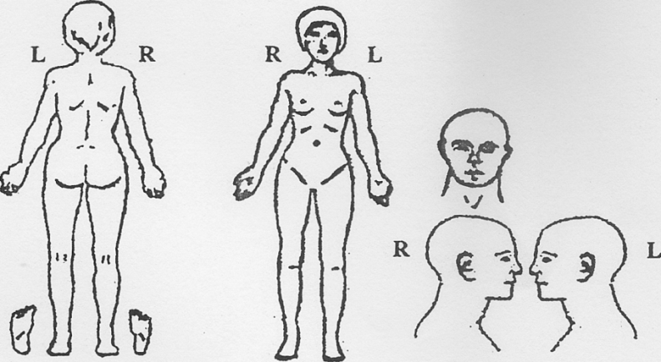

**Please check any additional symptoms you are having:**



Headache Hip Pain Numbness in Toes Face Flushed



Neck Pain Knee Pain Shortness of Breath Ear Pain



Neck Stiffness Chest Pain Fatigue Loss of Balance



Sleeping Problem Head feels Heavy Depression Fainting



Back Pain Pins and Needles in Arms Light bothers Eyes Dizziness



Nervousness Pins and Needles in Legs Loss of Memory Irritability



Tension Numbness in Fingers Ears Ring Diarrhea



Feet Cold Hands Cold Stomach upset Constipation



Shoulder Pain Frequent colds Frequent Fevers Pain with Menstruation



Do you exercise on a regular basis? How often?



What kind of exercise?



Where do you exercise?



Do you sleep on Other:



Do you sleep on Other:



Is your pillow Do you use a contour pillow?



Do you spend a lot of time sitting at a desk or in traffic?



Do you drink alcoholic beverages? How many drinks a day? a week?



Do you smoke? How many cigarettes a day? How many a week?

How many hours do you sleep a night? Do you sleep well or poorly?



Do you have an excessive amount of stress in your life right now?



Do you go to for Thai massage? How often?